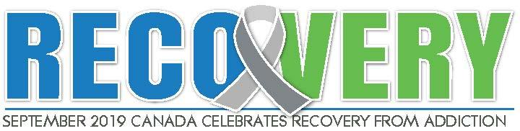
Thank you for your interest and contribution to Canada’s xth Annual Recovery Day celebrations. It is a great honor for all of us to share this time in making history with you.
These events are possible with the support of all of us in recovery- and those that support recovery- to be able to engage, have our story, our voice, and our passion serve a great purpose, of helping to break the stigma that surrounds this disease.
This toolkit has been put together to help you put together your own city’s Recovery Day celebration.
Our MISSION is to build awareness, challenge societal stigma and celebrate the role recovery plays in improving the lives of individuals, families and communities. We believe that recovery saves lives. We envision a world in which full recovery from addiction is a common and celebrated reality. We want to open up the conversation so that no one will ever experience shame when seeking help.
Recovery Day as it is now known started with an e-mail that was sent on July 30th, 2012 to AnnMarie McCullough and Lorinda Strang. It contained an eight minute trailer for the movie which at the time was still being produced by Greg Williams – known as ‘The Anonymous People’. The film documented the emerging “new recovery advocacy movement” with footage of rallies and marches that had been happening all over the US for a decade. After seeing the trailer, the decision was made to immediately start planning Canada’s first “Rally for Recovery” in Vancouver – with less than 8 weeks to prepare.
Before September 2012, no one had even heard the term “Recovery Day” in Canada but in a matter of weeks, we witnessed the birth- of not only a ‘Recovery Day’ in Vancouver, but also a Recovery Day in Victoria with proclamations in both cities that held events as well as a proclamation in Ottawa.
In September 2013, Vancouver, Toronto, Calgary, Edmonton, Saskatoon, Victoria, Regina, Nanaimo, Kamloops, Kelowna, Ottawa and Fredericton all hosted “Recovery Days” on September the 8th. The cities all had proclamations from their respective mayors. There were letters of support from the CCSA, CACCF, CASW and the health minister of BC. BC also received an unexpected proclamation from the premier declaring Recovery Day for the entire province.
Also that month, Lorinda and AnnMarie were in Washington, DC to receive an award for “rally of the year” from SAMHSA for Vancouver’s Recovery Day in 2012. It was announced that the UN was looking at passing a resolution to declare September "International Recovery" month which was passed in 2013.
In April of 2013, members of the Recovery Day initiatives - AnnMarie McCullough, Lisa Simone and Lorinda Strang formed a new organization-Faces and Voices of Recovery (FAVOR) Canada- modeled after the organization that has been helping organize the recovery movement in the US since 2001.
Faces and Voices of Recovery (FAVOR) Canada is dedicated to organizing and mobilizing Canadians in recovery from addiction, along with our families, friends and allies.
Our goals: to foster and build networks of recovery through community organizations and community centres; to reduce stigma; to raise awareness and to bring people together in celebration of recovery. Together, we will demonstrate the power and proof of recovery from addiction and its value to individuals, families and communities across Canada. We support all pathways to recovery and we STRONGLY support initiatives such as Recovery Day and Recovery Month.
In September 2018, over 30 cities celebrated Recovery Day events and this year, we hope to have even more cities joining in. The movement is gaining momentum!
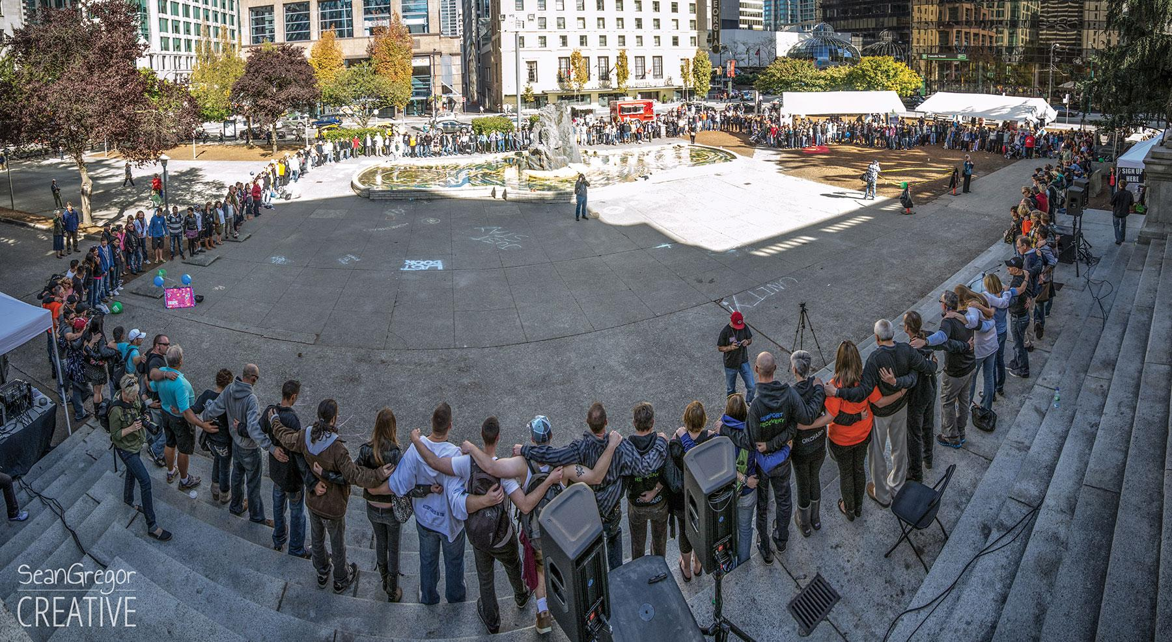

CONTENTS
4 | Proclamation Request
6 | Exhibitors Application
7 | Save the Date
8 | Volunteer
9 | Opportunities to Contribute Financially to Recovery Day
10 | Script for Recovery Day speakers
12 | Press Release sample
13 | Key Media Talking Points
14 | Recovery Message Training
17 | Critical Paths and Volunteer Spreadsheets

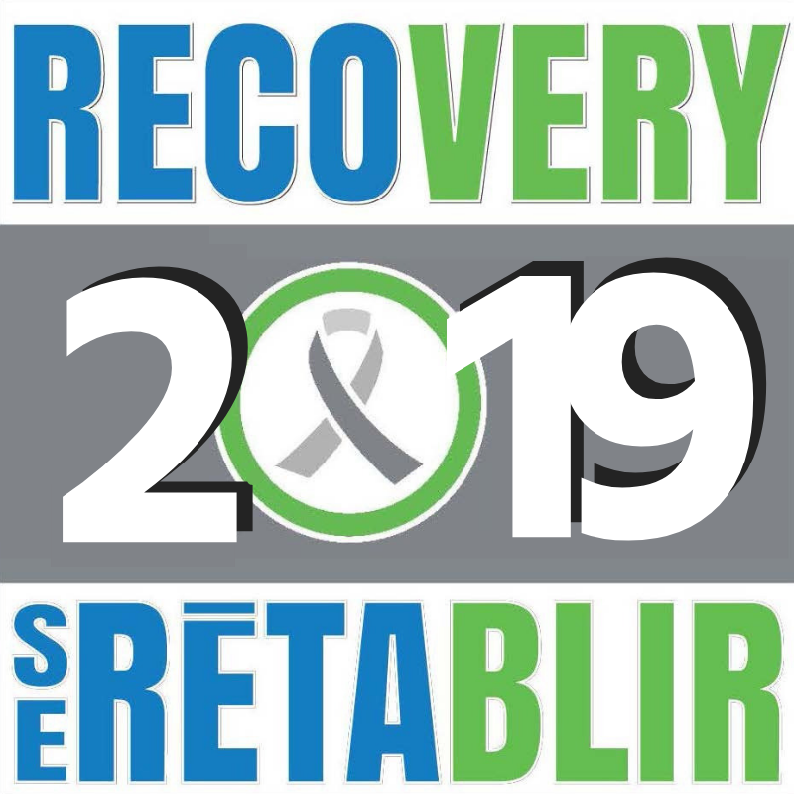
PROCLAMATION
RECOVERY DAY 201x
WHEREAS The disease of addiction in its various forms creates a tremendous burden to individuals, families and communities in the City of XX;
AND WHEREAS So many hundreds of thousands of steadfast and courageous citizens over the years have acknowledged their crippling dependencies and moved on to lives of sobriety;
AND WHEREAS So many have found again their dignity and self-respect and loving regard for themselves and those around them;
AND WHEREAS these brave souls have discovered and truly learned that honesty and sobriety and a full return to citizenship all march hand in hand;
AND WHEREAS many have until this day been reluctant to declare openly and without need for explanation that they live proudly in RECOVERY;
AND WHEREAS these very same people say in unison, “I AM IN RECOVERY,” and I am all the stronger and happier and more richly fulfilled as a person because of it;
AND WHEREAS we choose now to CELEBRATE our RECOVERY and the RECOVERY of those sons and daughters, brothers and sisters beside us;
NOW THEREFORE I, mayor name, Mayor of the City of xx, DO HEREBY PROCLAIM
insert date, as RECOVERY DAY in the City of XX.
Mayor Name

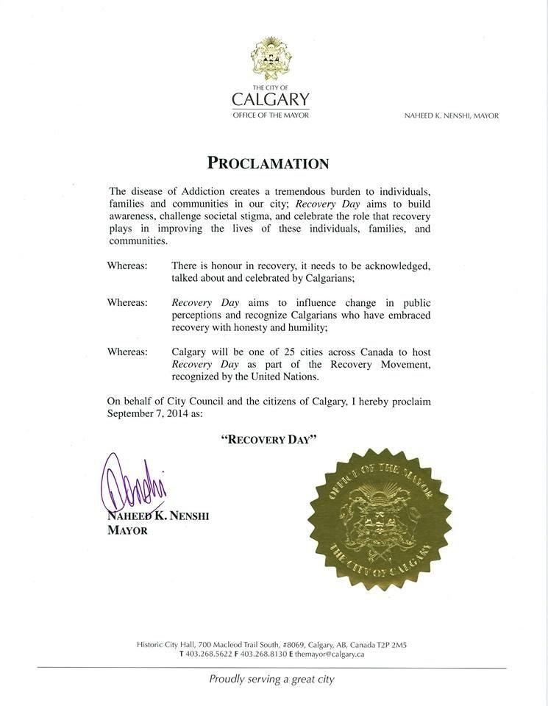
EXHIBITORS APPLICATION

With several thousand people “Rallying for Recovery” last year across Canada, the Recovery Day Rally in XXXXXX this year is sure to draw a huge crowd.
On September XXth you can take advantage of the opportunity to exhibit your program, agency, product or fellowship at the Recovery Day Rally – at XXXXXXX- insert location
Exhibitors Application:
Organization Name:
Address: City: PC :
Contact Name: Phone:
Contact Email:
Treatment Centre $ XXX Recovery Group (ie. AA, NA, etc.) $XXX
Amount Enclosed: $
Date: insert date and time
Exhibitor Set-up (insert time); take down (insert time).
Tents with tables and chairs will be provided.
Please make cheque payable to XXXXX:
Please complete this form and return to Recovery Day by insert date.
Email: xxxx@xxxx
Mail: insert mailing address

SAVE THE DATE
THE PROCLAMATION IS READY AND SO ARE WE!
With over XXXX people ‘Rallying for Recovery’ last year, this year we are expecting even more at the x Annual Recovery Day Rally and March.

On September XX JOIN us on RECOVERY DAY:
Where:
When:
What: Get involved by clicking on the forms below, filling out and emailing or faxing them back to the appropriate person:
- Becoming a financial supporter
- Volunteer – There are many volunteer opportunities
- Exhibiting at Recovery Day

Or just come and be a participant!
- Rally and March- bring all your clients, alumni, supporters of recovery!
- Bringing a banner or sign declaring a positive recovery
JOIN RECOVERY DAY TODAY
www.facebook.com/RecoveryDay ( add your FB page)
VOLUNTEER APPLICATION

201x Application:
With over xxxxx people rallying for Recovery last year, the X Annual Recovery Day March and Rally this year in insert city is sure to draw thousands.
YOU can volunteer on Day, September at the Annual Recovery Day Rally –XXXXXXXXX insert location.
All you have to do is tell us about you.
Name:

Phone: Email:

I CAN:

- Set Up/Clean up
- Security
- First Aid
- Sign language
- Hang posters/promote event
- Runner/traffic watch
- Photography/Videography
- Countdown table/info booth

Date: Day, September _, 201X– time – start and end

Please complete this form and return to Recovery Day by xxxxx, 201x.
Email: xxxx- insert volunteer coordinator email address

DONATIONS & FINANCIAL SUPPORT
201x Opportunities to Contribute Financially to Recovery Day/Donations
With thousands of people rallying for Recovery last year, the XX Annual Recovery Day March and Rally on __________________is sure to draw thousands.
Recovery Day is a joint effort of many organizations and requires financial support to stage the event. Costs include traffic control, sound system, tenting, tables, chairs, publicity, signage, and more.
Please join us as a financial supporter of Recovery Day 201x.
Financial Supporter Registration

Organization/ Company/ Individual Name:

Address:

City:

PC:

Contact Name: Phone:

Contact Email:

Amount Enclosed: $

Please make cheque payable to __________________
Please complete this form and return to Recovery Day by ___________________, 2017.
Email: ________________________
Mail: ________________________
Fax: ___________________________

SCRIPT FOR RECOVERY DAY SPEAKERS
For speakers in recovery:
Introduction
"My name is _________________ and I am a person in recovery/or long term recovery.
Concepts/Ideas to be portrayed in sharing:
- Circumstances of life experiences that perpetuated a life in addiction’
- Finding recovery and sharing what recovery has given you
- What "recovery" means to you
- Discuss whether the social stigma of addiction within society/institutions/organizations had any impact on your story
- How you see recovery impacting the community
- Impacts to the medical or criminal justice system

For presenters/speakers not in recovery:
Introduction
"My name is ___________________ and I am in support of recovery.
Ideas for sharing content:
- Feel free to discuss what recovery from addiction means for you, impact it may have had on your life, both personally or professionally
- Why you have chosen to participate and be involved with a recovery-based event
- Any related work you have done, or population you have been involved with where you have seen firsthand the impact and negative consequences of addiction as well as discussing solutions you have experienced (both those that have demonstrated positive results and those that are not working within our society).

Additional Guidelines:
The National Committee for Recovery Day requests that specifics regarding programs of recovery, treatment centres/facilities, anonymous fellowships, and spiritual paths not be disclosed during sharing.
Recovery from addiction can be found in a variety of ways and settings. While some may utilize 12 step programs, treatment centres, or professional counselling, others find recovery through religion, other spiritual experiences and some through “natural” recovery. The methods and specific details regarding how one has arrived in recovery is not the primary focus. Putting a face to recovery brings visibility to a way of living and a solution to the progressive and fatal illness of addiction. It portrays to the public at large a strong and positive image of those who have found recovery, hopefully reducing social stigma and the negative preconceptions of those afflicted with this disease. Recovery, no matter how an individual has arrived there, is something to be celebrated and supported, and shedding a bright light on what has long been kept in the dark will hopefully inspire others to seek assistance and bring about change within our societal systems.
Addiction is not isolated to the individual afflicted with the disease...it impacts family units, the medical community, the criminal justice system, and many other public and societal systems. Understanding this impact and having insight regarding both impact and strategies, whether positive or negative, will aid in providing direction for future endeavours. On the same note, the influence of recovery on the individual, family, and society as a whole is also pertinent to highlight and understand. We cannot change what we do not know, and having an open forum to portray the impact of both addiction and recovery holds great potential.

PRESS RELEASES
Xth ANNUAL RECOVERY DAY
Immediate Release
MEDIA RELEASE
September __, 201x– People suffering from addiction are often judged as having moral weakness. Even once they have found recovery, that stigma may continue. Recovering from an addiction is hard enough, but for many former substance abusers, even more difficult is dealing with society's judgment.
A new recovery movement is being organized at the local, provincial and federal level, one that is aimed at keeping the focus on the fact that recovery works and is making life better for millions of Canadians. Recovery Day aims to put a face and a voice on those who have found the solution. By sharing these success stories, those who are still suffering can see that recovery is possible.
Along with __30 other cities across Canada, (your city) is rallying and celebrating throughout the month of September to raise awareness and reduce stigma.
(Your City) ______ Annual Recovery Day takes place at ________ on (date) from (time). The event is being accompanied by an official proclamation by the Mayor, recognizing Recovery Day in the City. The celebration will include medical expert speakers, celebratory messages, personal stories of recovery and (#) booths representing (your city) recovery support services.
Our panel of speakers includes: (following is an Example of Calgary’s Recovery day speaker line up from 2014)
Honorable Mayor Naheed Nenshi,
Brian McGratten, NHL star, Calgary Flames and individual in long term recovery,
Dr. Michael Trew, Chief Medical Officer and Senior Medical director of Addiction and Mental Health,
Annie McCullough – Co founder, Faces and Voices of Recovery Canada & Recovery Day Canada,
Dr.Nicole Sheeren, Behavioral Neuroscientist, Scientific Director and Program Officer at The Norlien Foundation
Cory Hetherington – Chairperson of FAMH (Foundation of Addiction and Mental Health) and person in long term recovery.
Where: Address
When: Date and time
For media information or to arrange interviews contact: (name) (email) or (phone number)

KEY MEDIA TALKING POINTS
- We have seen the era of treatment; we are now in the era of recovery
- Recovery Day has grown from 2 events in 2012 to over 30 cities in 2018. We are continuing to add more cities as more people are inspired to participate
- There are over 1 million people in recovery in Canada - this is a constituency of consequence.
- When you add in friends, families, and allies, as much as 80-90% of the population are affected

RECOVERY MESSAGING TRAINING
by FAVOR CANADA
Trainers: Annie McCullough & Lisa Simone
What is a Message?
- An exchange of information using words
- The most important information you want your listener to hear
It is crucial that you know what you want to say and leave in people’s minds.
Grounded in Research:
Faces & Voices’ recovery messaging is based on research
  - Survey of the Recovery Community
  - Survey of the General Public
  - Focus groups of the recovery community & the general public (8 groups in 4 cities)
  - Conducted by Peter D. Hart & Associates & Robert M. Teeter’s Coldwater Corporation
  - www.facesandvoicesofrecovery.org/resources/public_opinion.php

Recovery Community:
  - 88% believe it is very important for the public to see that thousands get well every year
General Public- Destiny Project 2012:
  - A majority (83%) have been affected by addiction
  - A majority (67%) believe that there is a stigma toward people in recovery
  - A majority (74%) say that attitudes & policies must change

Who are You Talking to?
- Family
- Friends
- Neighbors
- Co-workers
- Media
- Public officials

Your Messaging Goals:
- Have effective, credible language that you can use to talk about your life and experiences
- Know how to use the message in different situations
- Make it possible for more people to
get well

Personalizing the Message:
- There are many ways to develop a message
- Messages aren’t designed as one-size-fits-all
- Our message has been adapted for many different groups:
  - People using medication in their recovery
  - Family members who have lost loved ones to addiction and others
  - Find your own voice by using these messages as a guide.

Frame of Mind:
- Speak with one voice
- Make it personal; it adds credibility and breaks down misperceptions
- Talk about your recovery, not your addiction – your recovery story

12-Step Anonymity:
- These messages don’t violate the traditions of 12-step fellowship
- Help us educate others in 12-step groups about their right to speak out!

Core Message

The Problem:
- Need more opportunities for people to achieve long-term recovery
- Need more effective treatment and recovery support services
- There are discriminatory policies
- The public and policymakers don’t know about the reality of recovery

The Solution:
- A strong national recovery movement organized at the local, provincial and federal levels
- Putting a face and a voice on recovery to break down misperceptions that will change attitudes (stigma)
- Advocating to change policies (discrimination)

What’s Not in the Message & Why
- I’m an addict (or alcoholic)
- I’m a recovering addict (or alcoholic)
- Addiction is a disease
- Information about 12-step programs, for examples membership in AA or NA or Al-Anon
- A “definition” of recovery

Recovery Messaging Resources:
- Recovery Messaging Questions & Answers
- The Tip Sheet for Media Interviews
- Our Stories Have Power DVD featuring interviews by people in recovery, family members and friends
- Visit www.facesandvoicesofrecovery.org www.facesandvoicesofrecovery.ca will soon have the trainings available for download
Faces & Voices of Recovery Website

Recovery Day Critical Path
Date of event
Time of event
Location of event
Event coordinator/contact person
Target audience – who
Who is this promotion targeted at?
What does the audience need to know?
What will hold their interest?

Message – what
What do you want to say to the target audience?
What do you want them to know/do?

Objectives – why
Be clear about what you hope to achieve with this event.

Description of event – what is Recovery Day?
Risk assessment – what
Identify possible risks and develop strategies to minimise risk
Evaluation criteria established
What were our aims/objectives?
Did we achieve what we set out to do?
Did it come in on budget?
What were the intended/unintended outcomes?
How do we measure effectiveness?
What tools do we use to measure our success?

Checklist
□ Who will be involved in the event
□ Date/s of event determined
□ Location/venue for event booked
□ Target audience determined
□ Message determined
□ Objectives set
□ Risk assessment completed
□ Evaluation criteria established

Budget, Invites | Assigned to | Action | Date to be  completed
Budget
□ Source identified
□ Sponsorship
□ Break-even point established?
□ Have you accounted for the GST?

Protocol
□ Request to invite VIP’s in writing and timely (six to eight weeks prior to event)
□ Protocol issues (relating to funding, attendees, etc.)
□ Anything that needs to be approved by Recovery Day team
□ Mayor’s office notified
□ Media and News notified
Invitations
□ Mailing list generated/updated
□ Invitation composed
□ Invitation checked
□ Printer
□ RSVPs
□ Invitation list compiled
□ Names on list and titles/addresses checked for accuracy
□ Special guests/speakers alerted to make time in diaries
□ Invitations sent

Media, Talent, Sound, Staffing, Accessibility | Assigned to | Action | Date to be completed
Advertising
□ Press, radio TV, school newsletter
□ Education News
□ Media release
Talent
□ Book and brief
□ Rehearsals
Signage
□ Organize plaques, banners if necessary
□ Other signage produced
Program/running sheet/speeches
□ Program finalized
□ Running sheet written
□ Program/running sheet sent to speakers
□ Speakers fully briefed
□ Speeches written
Security
□ Security alerted
□ Occupational health, welfare and safety concerns addressed
□ Provision of first aid
Audio/visual requirements
□ PA system
□ CD or tape player
□ Lapel or handheld microphone
□ Lighting
□ Extra electrical requirements
□ Lectern
Staffing
□ Extra required
□ Volunteers to meet and greet guests
Ambience
□ Floral arrangements, pedestal – can the theme of the event be followed in flowers?
□ Background music

Accessibility, Hospitality | Assigned to | Action | Date to be completed
Guest comfort
□ Wheelchair access
□ Toilet facilities
Hospitality
□ Welcome signage at entrance
□ Ushers briefed
Housekeeping
□ Cleaning before and after
□ On standby during the event
On the day
□ Time for set up by whom
□ Time for tear-down by whom
□ Dais, stage
□ Tables, chairs layout
□ Chair covers
□ Floor plan
□ VIP seating
□ Book courier/transport
□ Name tags
□ Clear location directions
□ Registration
After the event
□ Person responsible
□ Debrief
□ Guest feedback
□ Guidelines for improvement next time
□ Evaluation against criteria
□ Thankyou’s

2015 Recovery Day Calgary Production Schedule EXAMPLE ONLY:
TIME | RUN TIME |  | Guest | Description | COMMENTS
11:15:00 | 0:45:00 |  | Musical Guest | Musical guest set #1
12:00:00 | 0:05:00 |  | Lisa | Welcome Remarks | Mention ERP, bathrooms, Introduce musical guest and honored speakers
12:05:00 | 0:05:00 |  | MP | Read Proclamation personal remarks and introduce His Worship Mayor
12:10:00 | 0:07:00 |  | Mayor | His Worship Mayor
12:17:00 | 0:01:00 |  | Lisa | Introduce gratitude speaker #1 (Wendy)
12:18:00 | 0:05:00 |  | Wendy | Wendy Welcome Remarks and Introduce Annie | Thank RD volunteers
12:23:00 | 0:05:00 |  | speaker #1 | Annie | Bio--
12:28:00 | 0:00:30 |  | Lisa | introduce gratitude speaker #2 | Master of ceremonies
12:28:30 | 0:05:00 |  | speaker #2 | Paige | Person in Long Term Recovery
12:33:30 | 0:00:30 |  | Lisa | introduce gratitude speaker #3 | Master of ceremonies
12:34:00 | 0:07:00 |  | speaker #3 | Nicole | bio
12:41:00 | 0:00:30 |  | Lisa | Introduce gratitude speaker #4 | Master of ceremonies
12:41:30 | 0:05:00 |  | speaker #4 | Stacey | bio
12:46:30 | 0:00:30 |  | Lisa | Introduce gratitude speaker #5 (Norma) | Master of ceremonies
12:47:00 | 0:05:00 |  | speaker #5 | Norma Fuchs | Al-Anon bio. Who she is
12:52:00 | 0:00:30 |  | Lisa | Introduce gratitude speaker | Master of ceremonies
12:52:30 | 0:07:00 |  | speaker #6 | Dr.Michael | bio
12:59:30 | 0:00:30 |  | Lisa | introduce gratitude speaker #7 (Cory) | Master of ceremonies
1:00:00 | 0:05:00 |  | Speaker #7 | Cory Hetherington | bio
1:05:00 | 0:00:30 |  | Lisa | introduce gratitude speaker #8 (Brian) | Master of ceremonies
1:05:30 | 0:07:00 |  | Speaker #8 | Brian | bio
1:12:30 | 0:02:00 |  | Lisa | Prepare crowd for Serenity Prayer | Cue music while crowd gets in circle
1:14:30 | 0:01:00 |  | Group prayer | Serenity Prayer | Music continues (soft) increase volume when crowd reacts
1:14:30 | 0:02:00 |  | Lisa | Closing Remarks | Master of ceremonies

JOB | TIME IN | TIME OUT | PHONE NUMBER | DESCRIPTION | CONFIRMED
Set up |  |  |  | Help with banners, tables, misc ad hoc request
Set up |  |  |  | Help with banners, tables, misc ad hoc request
Set up |  |  |  | Help with banners, tables, misc ad hoc request
Set up |  |  |  | Help with banners, tables, misc ad hoc request
Set up |  |  |  | Help with banners, tables, misc ad hoc request
Setup |  |  |  | Banners- big one
First aid |  |  |  | Be available if needed
Vendor area manager |  |  |  | Make sure vendors know where they go
Information tent |  |  |  | Have info on event
Information tent |  |  |  | Have info on event
Information tent |  |  |  | Have info on drug prevention network
Info tent |  |  |  | Families & friends of recovery
Info tent |  |  |  | Have info on drug prevention network
Information tent |  |  |  | Have info on drug prevention network
Recovery countdown |  |  |  | Add and keep track of celebrations
Recovery countdown |  |  |  | Add and keep track of celebrations
Recovery countdown |  |  |  | Add and keep track of celebrations
Recovery countdown |  |  |  | Add and keep track of celebrations
March marshalls |  |  |  | Start off march
March marshalls |  |  |  | Start off march
March organizer |  |  |  | Gather the crowd to march
March organizer |  |  |  | Gather the crowd to march
March organizer |  |  |  | Gather the crowd to march
Street support |  |  |  | At intersection to make sure march obeys traffic signal
Street support |  |  |  | At intersection to make sure march obeys traffic signal
Street support |  |  |  | Watch sidewalk to make sure people stay on it
Street support |  |  |  | At intersection to make sure march obeys traffic signal
Street support |  |  |  | At intersection to make sure march obeys traffic signal
Street support |  |  |  | Watch sidewalk to make sure people stay on it
Street support |  |  |  | Watch sidewalk to make sure people stay on it
Stage "goon" |  |  |  | Keep people off stage
Stage "goon" |  |  |  | Keep people off stage
Stage "goon" |  |  |  | Keep people off stage
Balloons |  |  |  | Inflate balloons
Balloons |  |  |  | Inflate balloons
Pictures of banners |  |  |  | Take pics of the sign/banners for the contest- 12-2pm
Pictures of banners |  |  |  | Take pics of the sign/banners for the contest- 12-2pm
Video taping of event |  |  |  | Video taping
Clean up |  |  |  | Leave nothing behind
Clean up |  |  |  | Leave nothing behind
Clean up |  |  |  | Leave nothing behind
Clean up |  |  |  | Leave nothing behind
Clean up |  |  |  | Leave nothing behind
Clean up |  |  |  | Leave nothing behind
Tear down |  |  |  | Same people as set up
Tear down |  |  |  | Same people as set up
Tear down |  |  |  | Same people as set up
Tear down |  |  |  | Same people as set up
Tear down |  |  |  | Same people as set up
Tear down |  |  |  | Same people as set up
Donation jugs |  |  |  | Collect donations
Donation jugs |  |  |  | Collect donations
Photographer |  |  |  | Take photos
Photographer |  |  |  | Take photos
Sign language interpreter |  |  |  | Sign language

